**Ideation Phase**

**Brainstorm&Idea Prioritization**

|  |  |
| --- | --- |
| Date | 19 September 2022 |
| Team ID | PNT2022TMID43270 |
| Project Name | Signs with Smart Connectivity for Better Road Safety |
| Maximum Marks | 1. Marks |

**1.Introduction**

In its Global Status Report on Road Safety – 2015, the World Health Organization (WHO) noted that the worldwide total number of road traffic deaths has placed at 1.25 million per year, with tens of million either injured or disabled [1]. Different initiatives, such as the United Nations’ initiative for the 2011-2020 Decade of Action for Road Safety, have led to improvements in road safety policies and enforcements. However, the WHO notes that the progress has been slow and has maintained the call for urgent action to reduce these figures [2]. Added to the losses in human lives and wellbeing, considerable monetary losses are incurred in medical expenses, infrastructure repair, and production downtime. While the worldwide figures have placed, the Global Status Report does indicate higher road fatalities and injuries in low income countries. Such disparity, as noted in [3], signals a barring-limitation in low-income countries to improve road safety by adopting solutions implement

1. **Step-1: Team Gathering, Collaboration and Select the Problem State Brainstorm & Idea Prioritization :**

## What is Brainstorming?

In a nutshell, brainstorming is one of the most creative ways of problem-solving in which we work on ideas. We can either come up with a new idea or build on an existing idea as well. Since there is no rule of thumb in brainstorming, it can be applied individually or in a group.

* Firstly, a goal is defined to understand what the main purpose of brainstorming is.
* Once we have an end-goal to achieve or a problem to solve, various challenges that come along are explored.
* Furthermore, different aspects of the problem or situation are explored and we list down ways to overcome the challenges.
* There is no structure in brainstorming, and no idea is considered wrong. All ideas are noted during the brainstorming sessions, and some can even be clubbed together.

Let’s consider that you need to work on a marketing plan for your brand. Firstly, you will define its objective and the vision of the brand. Subsequently, you will work on other things like the promotional strategy, what the customers think, the pricing, and what your competitors are doing. After considering all these things in mind, you can come up with a new and exciting marketing plan.

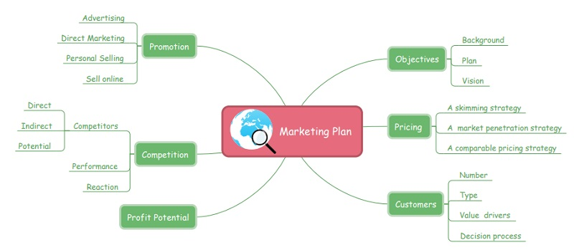

Te Safe System (SS) approach to transport networks originated with the “Safe Road Transport System” model developed by the Swedish Transport Agency. In its essence, the approach migrates from the view that accidents are largely and automatically the driver’s fault to a view that identifices and evaluates the true causes for accidents. Trough the categorization of safety into the safety of three elements (vehicle, road, and road user), SS minimizes fatalities and injuries by controlling speeds and facilitating prompt emergency response. Te model has been widely adopted since its introduction and is currently motivated by the WHO as a basis for road safety planning, policy-making, and enforcement. An illustration of the model is provided in Figure 1. A central emphasis is given to speed in the SS approach as it is the strongest and most fundamental variable in the Hi Wireless Communications and Mobile Computing Volume 2018, Article ID 8214989, 11 pages https://doi.org/10.1155/2018/8214989 2 Wireless Communications and Mobile Computing A Safe Road Transport System Safe Speed Safe Vehicle Safe Road Safe Road User Biomechanical limits that the road user can tolerate without sustaining severe injury Figure 1: Te Safe-System-based Safe Road Transport Systems, with its elements: safe vehicle, safe road, and safe road user [5]. outcome of fatality. Te fragility of the human body makes it unlikely to survive an impact at a speed of more than 30 km/h, with lower speeds resulting in either death or serious injury [3, 4]. Te objective of the SS approach is that the three model elements should be designed and monitored to proactively prevent deadly speeds from happening and allow for a reduced emergency response time in the event of an accident. Elements of the SS approach are as follows. (1) Safe Vehicle. Emphasis on vehicle safety is verified through mandated regulatory testing and rating, as well as technologies such as electronic stability control. Beyond this, enforced checks (e.g., upon license renewals) combined with on the road reporting work to review the status of vehicle safety. (2) Safe Road. Te assessment of road (or road network) safety is multifaceted. Road inspection enables clear and direct observation of the state of the road and assesses the need for repairs or modifications. Te structure of the road network is amenable to safety assessment through partitioning into what is called “Traffic Analysis Zones (TAZs)” [8]. In addition, considerations for crash data and other supporting data offer further insights into general safety assessment. In 2011, the European Road Assessment Programme generated the European Road Safety Atlas for EU countries [9]. Te atlas indicated the safety level of roads with a star rating based on specially equipped vehicles for multimedia-based data aggregation [10]. Te Euro efforts continue to implement an SS approach across the EU, along with several other national programmes within the International RAP, or , initiative [11]. (3) Safe Road User. There are several aspects to road user safety, including measures for education and awareness, travel distance, exposure, licensure, enforcement, and sober driving [5]. Te need for such characterization rises substantially as the findings of crash report analysis in cities typically note a critical dependence on either driver behavior or driver awareness [12]. A great need is further established in these studies for innovative mechanisms to instilled safe driving at the licensing and post-licensing stages. 1.2. Contributions. Figure 2 illustrates elements of assessing road safety. It can be seen in the figure that the scope of consideration in the SS approach is medium-to-long term, facilitating by design, systemic actions that are made to ensure the safety of the road network. While the use of “data monitoring systems” is motivated in [4] and can be utilized for shorter term scopes, the general emphasis is maintained at the medium-to-long term reaction cycles. Our interest in this work is to extend SS .

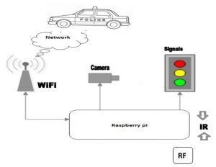

**Step-2: Brainstorm, Idea Listing and Grouping**

### Mind Mapping

Mind mapping is a fairly common term nowadays — in fact, many types of software provide automated [mind-mapping templates](https://www.mindmeister.com/?utm_source=gad&utm_medium=search&utm_campaign=-us_en-&utm_content=mm&gclid=EAIaIQobChMIj6eFwNve3QIVm4uzCh1Q-w-eEAAYASAAEgJGE_D_BwE) so you can better organize your data. Well, it also happens to be a great way to organize your ideas.

* To create a mind map for creativity purposes, write down the task or problem you're trying to solve at the center of your idea sheet (feel free to do this on your computer, but whiteboards are ideal).
* Then, expand on this problem by surrounding it with terms that better describe what you need. If your problem is low website traffic, for example, some terms to write around this phrase might be "organic traffic," "trusted content," "SEO," and "video strategy."
* Once your mind map has this first layer, add a second layer to each of your needs describing how you might be able to solve for these individual challenges. Around "SEO," you might write "[**topic clusters**](https://blog.hubspot.com/marketing/content-marketing-strategy)," "dedicated SEO strategist," and "video marketing course."

Keep adding to your mind map using the steps above until you've sufficiently broken down your problem into manageable parts. It's a fantastic problem-solving technique that fosters creative answers to subjects that might otherwise seem uninspiring.

## Step-3: Idea Prioritization

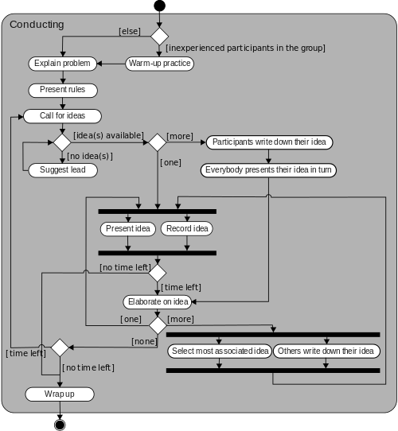

## Group Brainstorming Techniques

### Group Sketching

### Brain Netting

### Questioning Assumptions

### Wishing

### Alter-Egos / Heroes

### Six Thinking Hats

## How to Brainstorm Ideas

1. Focus on quantity over quality.
2. Selectively apply constraints to keep the session focused.
3. Don’t prune ideas as you brainstorm.
4. Never finalize or commit during the brainstorming session.
5. Look to other sources for inspiration.
6. Use a whiteboard (and take pictures of each white boarding session).
7. Take breaks.

**Conclusion**

We have presented a system, to alert the driver about the speed limits in specific areas and reduce the speed of the vehicles in sensitive public zones without any interference of the drivers where controls are taken automatically by the use of a wireless local area network. In the initial phase, we designed the basic block and circuit diagram for the system. In the implementation phase, we executed the hardware with the help of IoT connecting tecnologies such as Blynk app. Extensive experiments conducted on IoT and other connecting technologies.

**Future enhancement**

We can be enhanced this system by implementing camera using Raspberri pi, GSM module in case of network unavailability and low RAM module/zigbee module for long range communication.